PROJECT REPORT TEMPLATE

VEHICLE MANAGEMENT SYSTEM USING SALESFORCE

1 INTRODUCTION

1.1 Overview

A Vehicle Management system to a software system or platform that serves to manage commercial fleets of vehicles such as cars, vans or trucks or even heavy equipment to ensure they are utilized safely, efficiently and professionally, while making sure they are well maintained and high performing.

1.2 Purpose

Depending on the type of Vehicle Management system

* Improve fleet safety and working conditions
* Improve the behaviours and performances of drivers and beat unsafe driving
* Schedule shifts and work hours
* Manage fuel efficiently
* Track vehicles, assets or professional equipment

2. Problem Definition & Design Thinking

2.1 Empathy Map

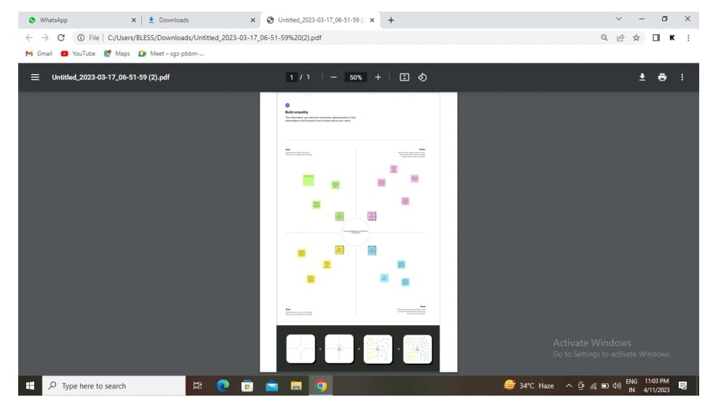

2.2 IDEATION & BRAINSTORMING MAP

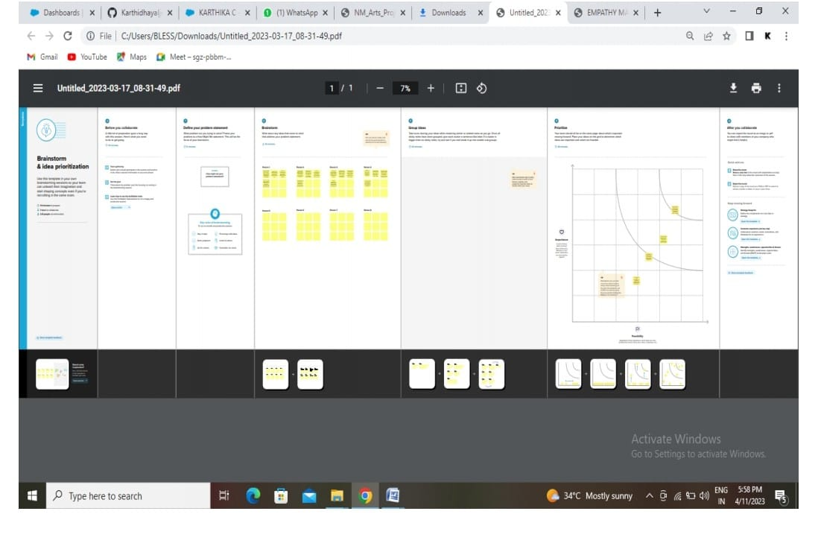

3 RESULT

3.1 DATA MODEL

|  |  |
| --- | --- |
| OBJECT NAME | FIELDS IN THE OBJECT |
| OBJECT 1 | |  |  |  | | --- | --- | --- | | S.NO | FIELD LABEL | DATA TYPE | | 1 | Customer name | Text | | 2 | Customer mobile no | Number | | 3 | Vehicle Type  i) 2 Wheeler  ii) 4 Wheeler | Picklist | | 4 | 2 Wheeler  i) HERO  ii)HONDA  iii) BAJAJ  iv) ROYAL ENFIELD  v) TVS  vi) KINECTIC  vii) OLA  viii) JAWA  ix) SD  x) BATTERY | Picklist | | 5 | 4 Wheeler  i) RENAULT  ii) SKODA  iii) HONDA  iv) HYUNDAI  v ) SUZUKI  vi) MAHINDRA  vii) VOLKSWAGEN  viii) BENZ  ix) AUDI  x) VOLVO | Picklist | | 6 | Vehicle name | Text | | 7 | Vehicle no | Text | | 8 | Chassic no | Text | | 9 | Colour | Text | | 10 | Body Type | Text | | 11 | Vehicle Includes  i) FIRE EXTENUATION  ii) FIRST AID KIT  iii) MULTI CHARGER KIT  iv) STEPNEY  v) STEREO  vi) TOOL KIT  vii) TRACKING DEVICE  viii) TYRE JACK | Multi Picklist | | 12 | Condition  i) Good  ii) Medium  iii) Least | Picklist | | 13 | Mileage | Text | | 14 | Seats | Number | | 15 | Start Date | Date /Time | | 16 | End Date | Date/Time | | 17 | Opportunity | Lookup(Opportunities) | |
|  |  |

|  |  |  |  |  |  |  |  |  |  |  |  |  |  |  |  |  |  |  |  |
| --- | --- | --- | --- | --- | --- | --- | --- | --- | --- | --- | --- | --- | --- | --- | --- | --- | --- | --- | --- |
| OBJECT 2 | |  |  |  | | --- | --- | --- | | S.NO | FIELD NAME | DATA TYPE | | 1 | Driver name | Text | | 2 | License no | Text | | 3 | Mobile no | Number | | 4 | Fair Per Hour | Text | | 5 | Vehicle | Lookup(Vehicle) | |

3.2 ACTIVITY & SCREENSHOT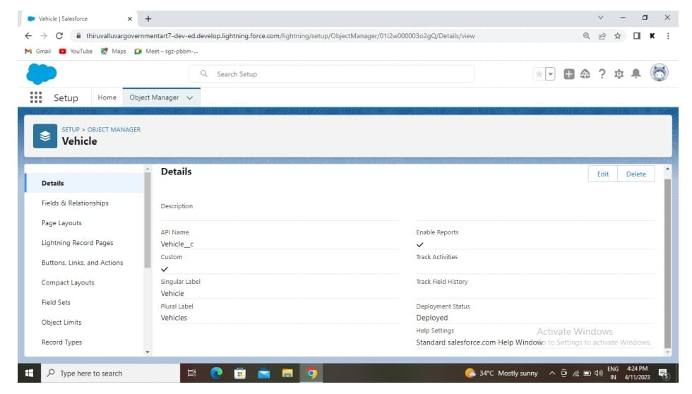

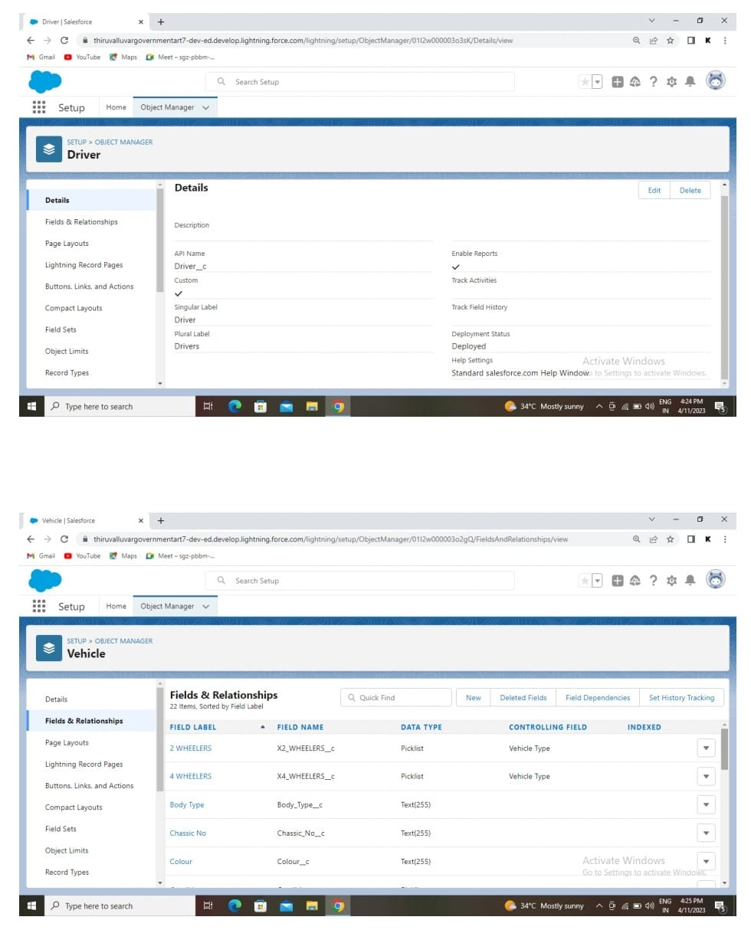

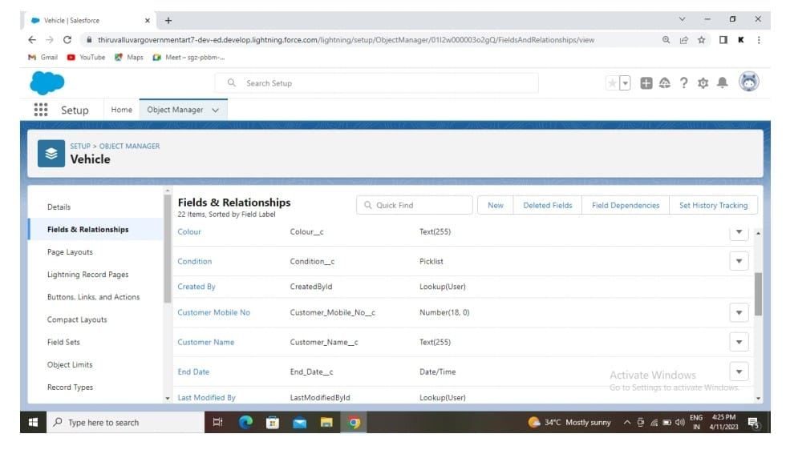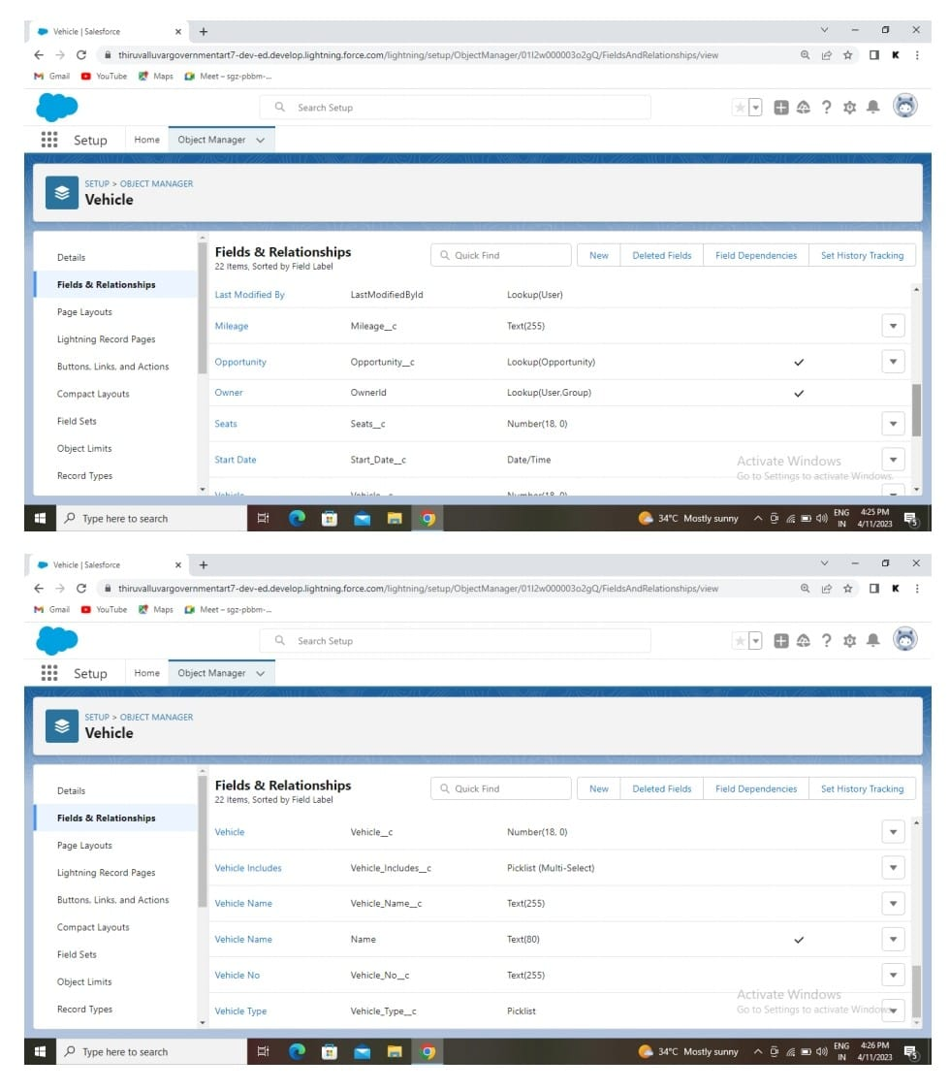

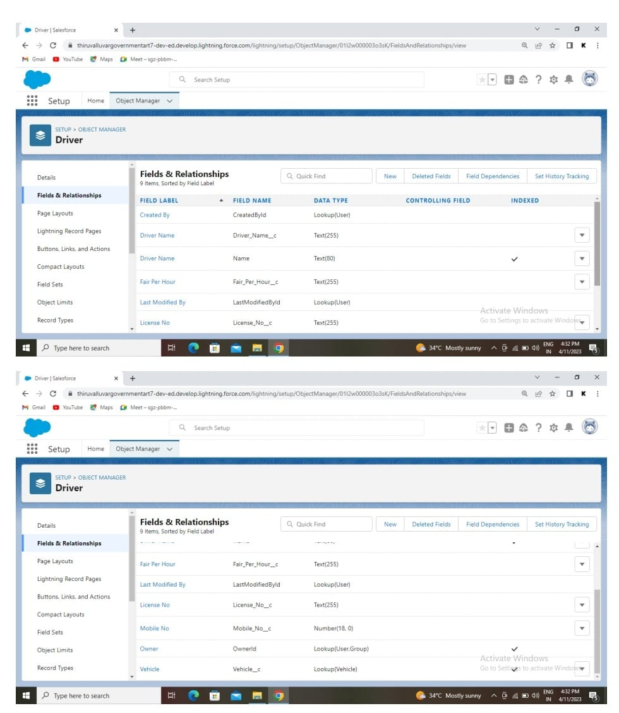

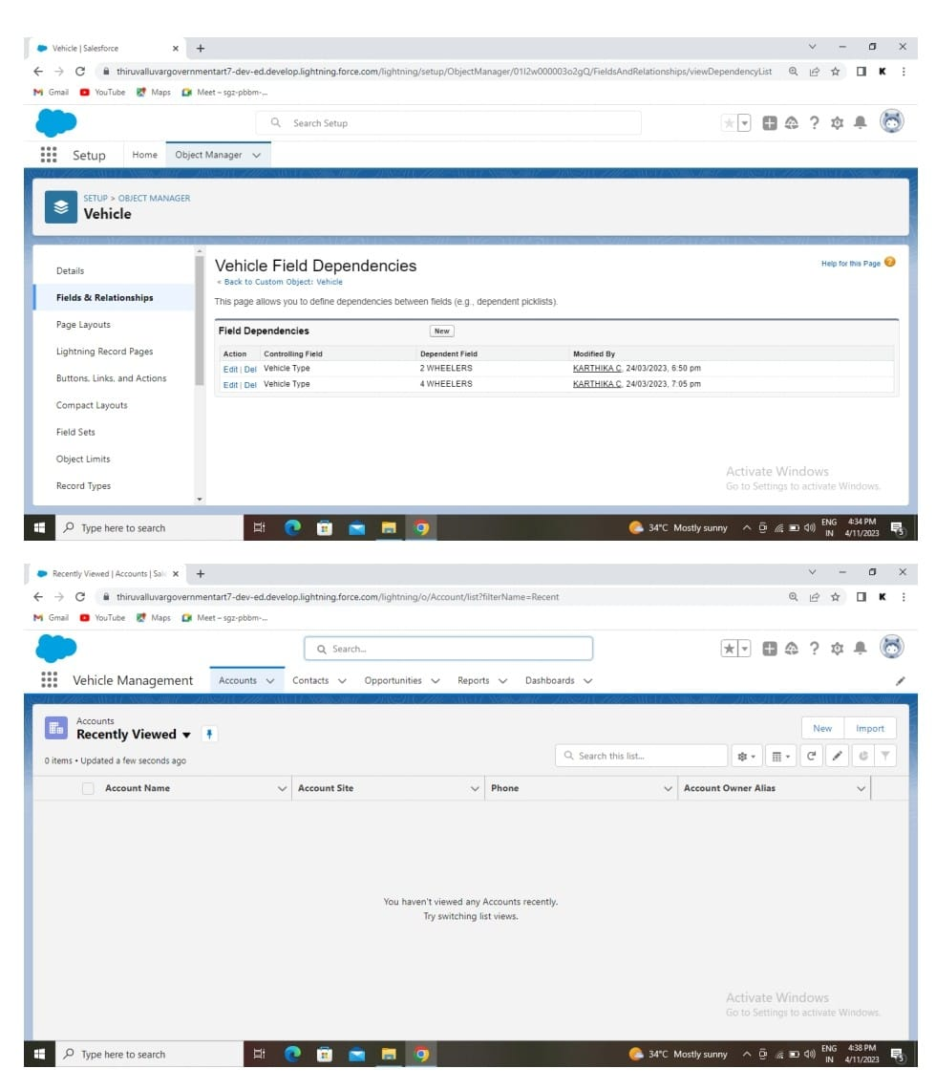

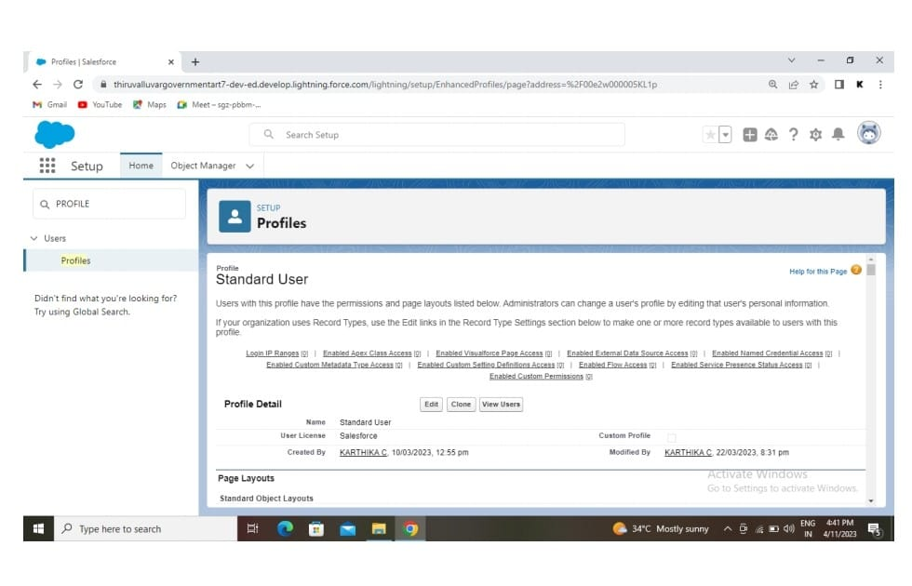

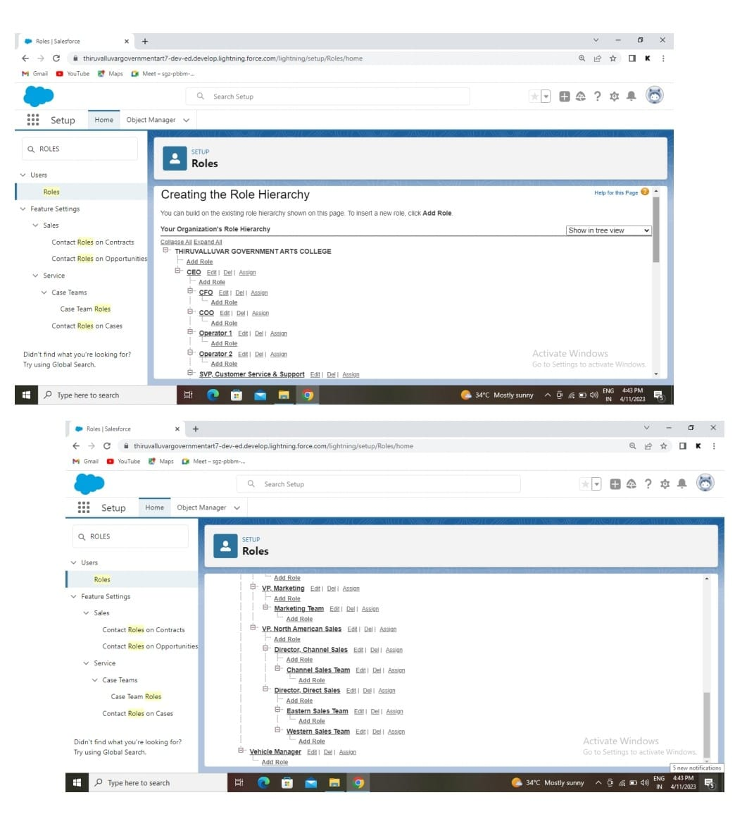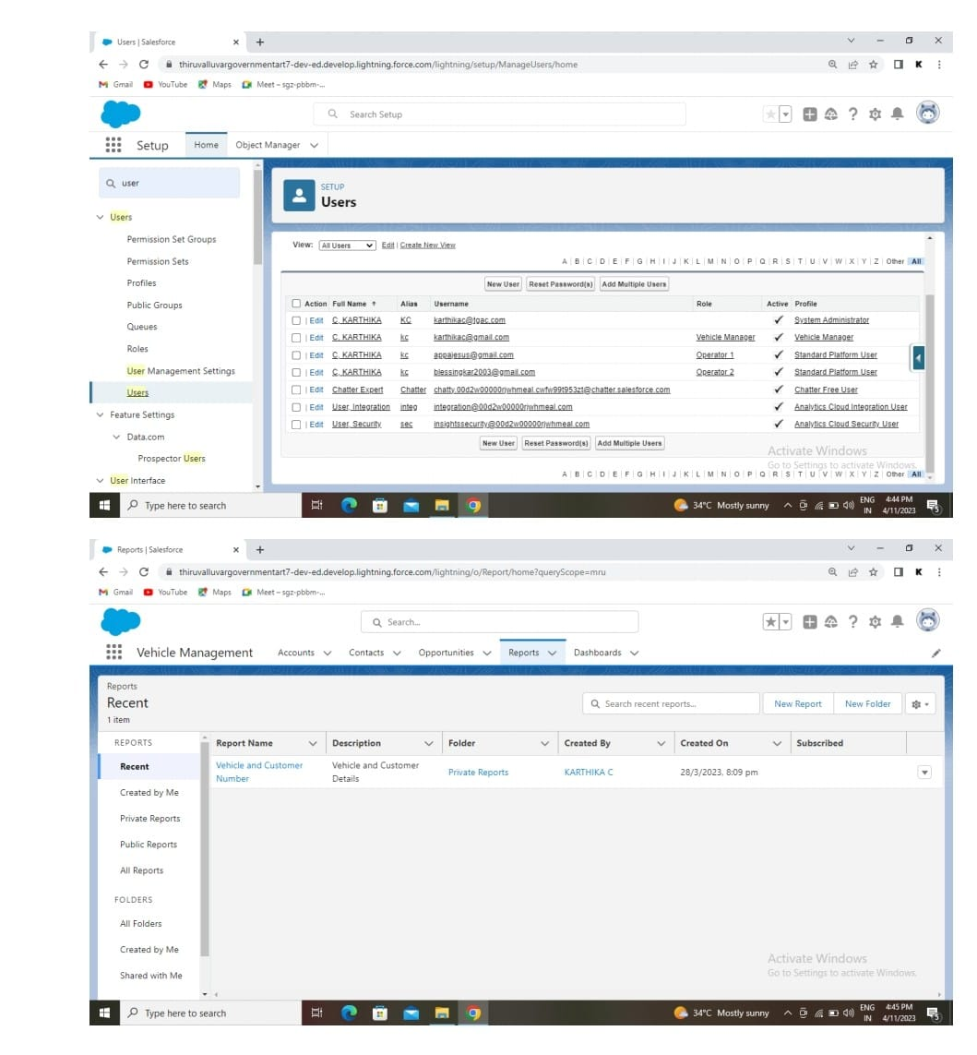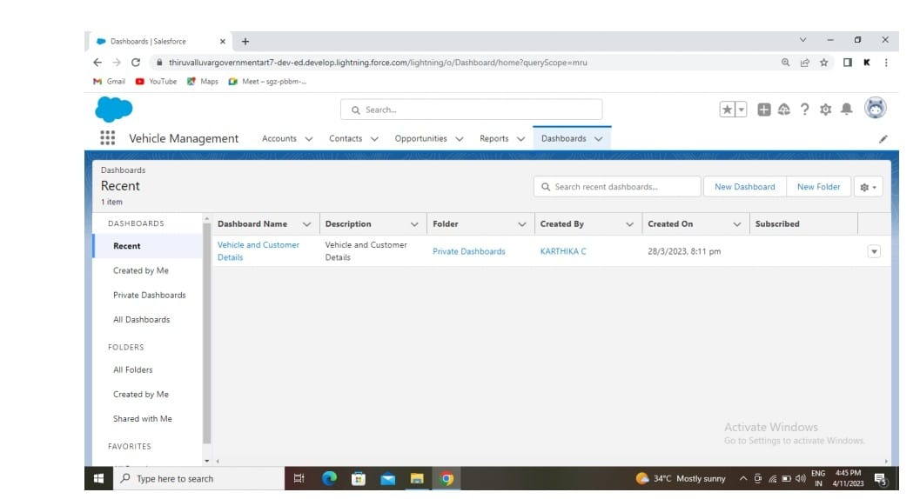

4 TRAILHEAD PROFILE PUBLIC URL

Team Leader:

Team Member 1:

Team Member 2:

Team Member 3:

5 ADVANTAGES

* Easy to manage and cost-effective
* Because of that there is no towing problems
* No human employee is required

DISADVANTAGES

1. Vehicle stand does not specified current location in the parking fields

6 APPLICATIONS

The applications of vehicle Management are

1. Market place
2. Colleges/Schools
3. Enterprises and Institutions
4. Hospital
5. Factory

7 CONCLUSION

1. Use this project for industrial purposes in a wide range
2. Low cost
3. The accuracy of this project may be improved by adding some features

8. FUTURE SCOPE

In the modern age, many people have vehicles. Vehicle is now a basic need. Every place is under the process of urbanization. There are many corporate offices and shopping centres etc. There are many recreational place where people used to go for refreshment. So, all these places need parking space where people can park their vehicles safely and easily. Every parking are needs a system that records the detail of vehicles to give the facility. These system might be computerised or non-computerised. With the help of computerized system we can deliver a good service to customer who wants to park their vehicle into the any organization’s premises

Trialhead URLS;

<https://trailblazer.me/id/sadhimoolam1>

<https://trailblazer.me/id/dharunrajsivam2002>

<https://trailblazer.me/id/prema87>

https://trailblazer.me/id/manis1329